GRADE 7 ACCELERATED · UNIT 2  Reference Sheet  Real Numbers, Square Roots and Cube Roots — keep this in your binder | Name_________________  Period_______________

1. The Numbers You Have to Know Cold
Perfect squares, 1 to 225.
1² = 1 | 2² = 4 | 3² = 9 | 4² = 16 | 5² = 25 | 6² = 36 | 7² = 49 | 8² = 64
9² = 81 | 10² = 100 | 11² = 121 | 12² = 144 | 13² = 169 | 14² = 196 | 15² = 225

Perfect cubes. The first two rows are the ones the test stays inside. The third is past that range and still turns up on the worksheets and in the study guide, so learn it too.
1³ = 1 | 2³ = 8 | 3³ = 27 | 4³ = 64 | 5³ = 125
(−1)³ = −1 | (−2)³ = −8 | (−3)³ = −27 | (−4)³ = −64 | (−5)³ = −125 | 0³ = 0
6³ = 216 | 7³ = 343 | 8³ = 512 | (−6)³ = −216 | (−7)³ = −343 | (−8)³ = −512

These two lists carry the whole unit. Every question about roots, ordering and estimating comes back to them. Write them from memory once a night for a week and the rest is easy.
2. Square Roots and Cube Roots
The radical sign names ONE number. It is called the principal square root, and it is never negative.
The radical sign | The equation
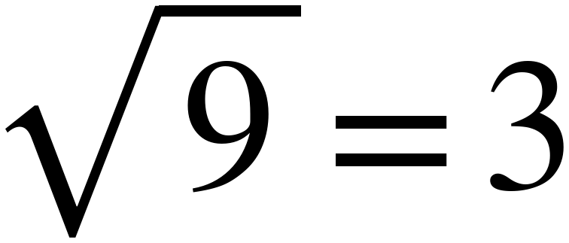 | 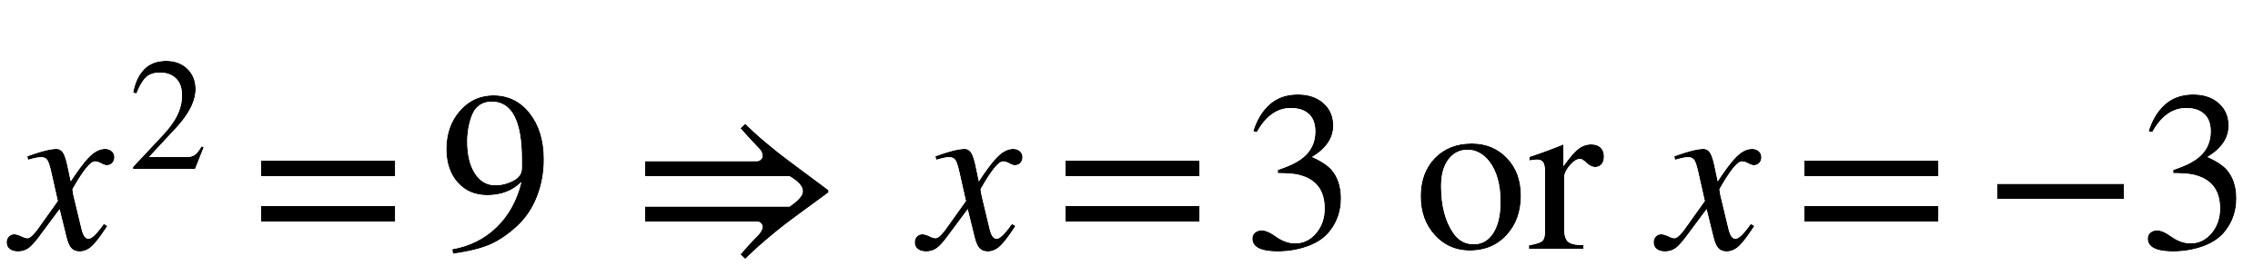
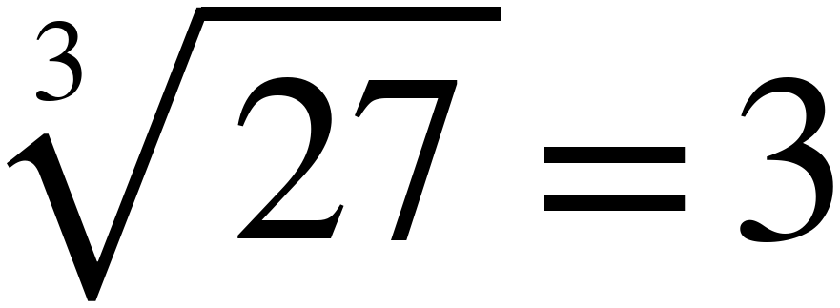 | 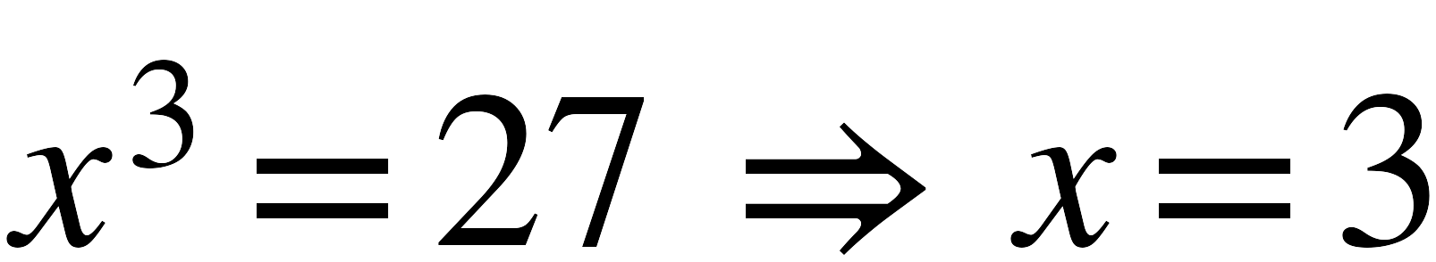

- A minus sign in front of a radical is applied after the root: −√169 = −13.
- A minus sign inside a square root has no real answer: √−49 is not a real number.
- A minus sign inside a cube root is fine: ∛−27 = −3.
3. Solving x² = p and x³ = p
Equation | How many real solutions | Why
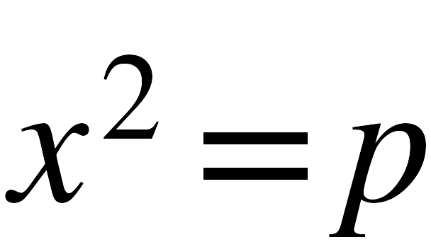 , p > 0 | two | one positive, one negative, and both square to p
, p = 0 | one | only 0 squares to 0
, p < 0 | none that are real | nothing squared is negative
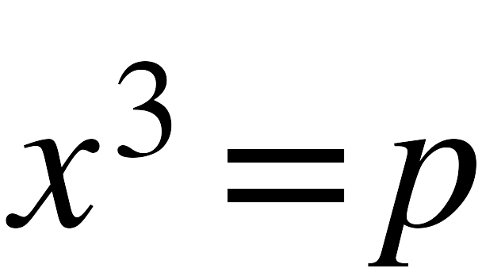 | exactly one, always | a cube keeps the sign of its root

Squares come in pairs. Cubes do not. That one sentence answers most of the select-all questions on this benchmark.
Watch the wording. “Evaluate √64” asks for one number, 8. “Solve x² = 64” asks for every number that works, 8 and −8. Same 64, different question.
4. Estimating a Root from the Perfect Squares and Cubes
Four steps.
- Find the two perfect squares (or cubes) the number sits between.
- The root sits between their roots.
- Compare the two distances to decide which one it is closer to.
- For the nearest tenth, test two decimals: square (or cube) each and see which lands nearer.
Worked example. √52. 49 < 52 < 64, so √52 is between 7 and 8. 52 − 49 = 3 and 64 − 52 = 12, so it is much closer to 7. Test: 7.2² = 51.84 and 7.3² = 53.29 — 51.84 is nearer, so √52 ≈ 7.2.
Round LAST, not first. Adding and subtracting are safe. Multiplying and dividing are not. If a question says 4√11, keep √11 ≈ 3.3166 and multiply, then round: 13.3. Rounding to 3.3 first gives 13.2, which is wrong.
Careful with cube roots. Comparing distances works every time for square roots. For a cube root it is only a first guess. ∛44 is nearer 27 than 64, but ∛44 ≈ 3.53, which is closer to 4. When a cube root looks near halfway, cube the halfway value and compare: 3.5³ = 42.875, and 44 is bigger than that, so ∛44 is past 3.5.
Values worth memorizing. 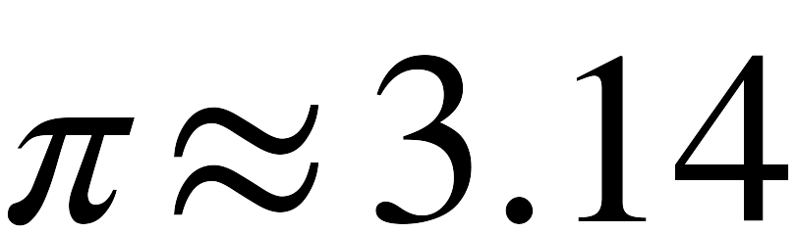 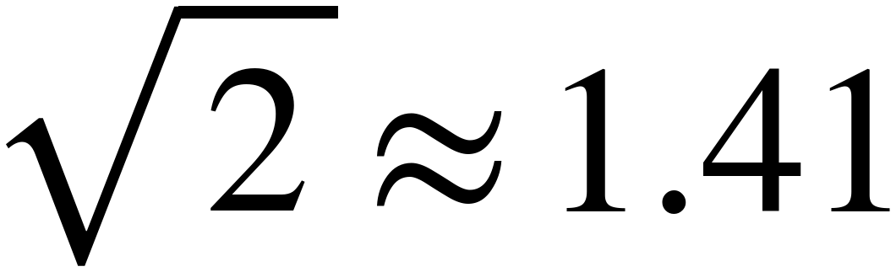 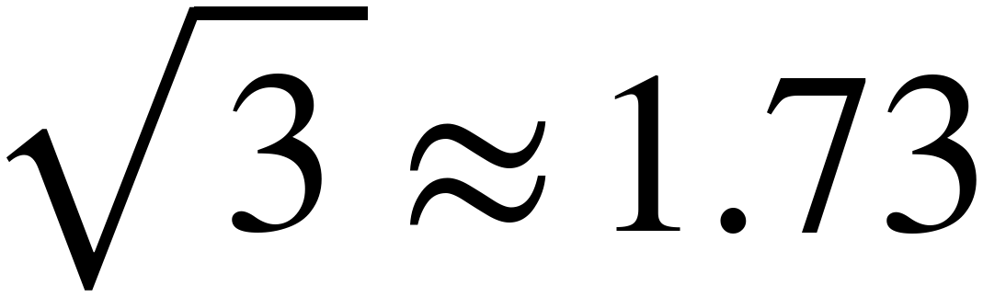 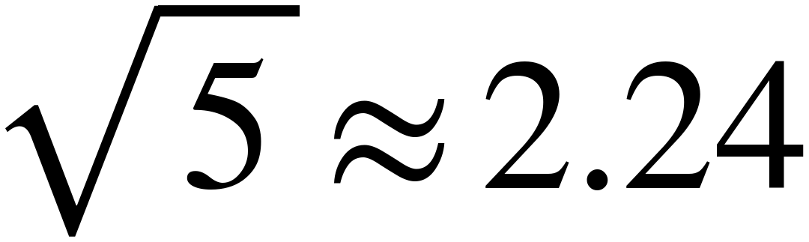
5. Rational or Irrational
Rational | Irrational
any fraction of two INTEGERS (−13/5 counts) | π, and π times any NON-ZERO rational number
any terminating decimal (0.75, −1.4) | a square root of a positive INTEGER that is not a perfect square
any repeating decimal (0.4444…) | a cube root of an INTEGER that is not a perfect cube
any whole number or integer | decimals that never end and never repeat
a root that comes out even (√49, ∛8)

The test is what the number EQUALS, not what it looks like. √49 has a radical sign and is rational, because it equals 7. −0.5√36 equals −3, so it is rational too. Work the value out first, then decide.
22/7 is not π. It is a fraction of two integers, so it is rational. It is only an approximation of π, which is irrational.
6. Plotting, Ordering and Comparing
- Turn every number into a decimal estimate first. Compare the decimals, then write the answer in the original forms.
- Check the scale on a number line before you plot anything. Count the spaces between two labeled numbers and divide.
- With negatives, the order flips: −√50 < −2π < −∛20. The bigger the root, the further left it sits.
- To compare a POSITIVE root with a positive plain number, square (or cube) the plain number instead of estimating the root. √26 vs 5.2: 5.2² = 27.04, and 26 < 27.04, so √26 < 5.2. No estimating at all. With negatives, compare the positive versions first and then turn the answer round: −√20 vs −4.5 → √20 vs 4.5 → 20 < 20.25 → √20 < 4.5 → −√20 > −4.5.
7. Vocabulary
real number — every number that can be plotted on a number line. Rational and irrational numbers together.
rational number — a number that can be written as a fraction of two integers. Its decimal terminates or repeats.
irrational number — a real number that is not rational. Its decimal never ends and never repeats.
perfect square — a number that is some whole number multiplied by itself. 1, 4, 9, 16, …, 225.
perfect cube — a number that is some integer multiplied by itself three times. …, −512, −343, −216, −125, −64, −27, −8, −1, 0, 1, 8, 27, 64, 125, 216, 343, 512, … The test stays between −125 and 125; the ones past that still appear on the worksheets.
square root — a number that, multiplied by itself, gives the value under the radical sign.
principal square root — the square root that is never negative — the one the radical sign means. √64 = 8, not −8; and √0 = 0, which is why the definition says never negative rather than positive.
cube root — a number that, multiplied by itself three times, gives the value under the radical sign. Every real number has exactly one.
radicand — the number underneath the radical sign. In √52 the radicand is 52.
index — the small number in the notch of the radical sign. It is 3 for a cube root, and it is left off for a square root.
approximate — give a value close enough to be useful. The symbol is ≈.
terminating decimal — a decimal that stops. 0.375 stops after three places.
repeating decimal — a decimal with a digit or block that repeats forever, written with a bar over the repeating part.

